Increased transparency and documentation of private sector contributions to NDCs

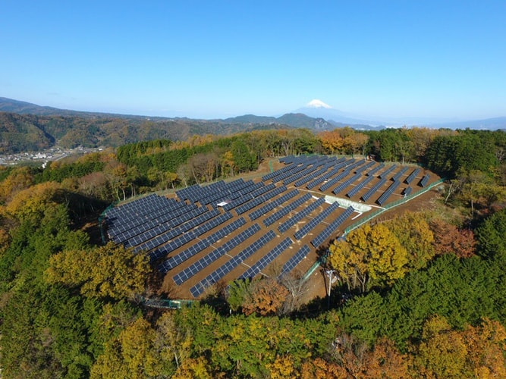

Guidance for companies wishing to adopt an existing protocol to report on their greenhouse-gas emissions
May 2021

Project title:
Increased transparency and documentation of private sector contributions to NDCs

Deliverable title:
Guidance for companies wishing to adopt an existing protocol to report on their greenhouse-gas emissions

Authors:
Daniel Puig (UNEP DTU Partnership, UDP)
Fatemeh Bakhtiari (UNEP DTU Partnership, UDP)

COPYRIGHT©
This publication may be reproduced in whole or in part and in any form for educational or non-profit purposes without special permission from the copyright holder, provided acknowledgement of the source is made. UNEP DTU Partnership (UDP) would appreciate receiving a copy of any publication that uses this publication as a source. No use of this publication may be made for resale or for any other commercial purpose whatsoever without prior permission in writing from UDP.

DISCLAIMER

This publication has been produced as part of a component of the Initiative for Climate Action Transparency project (ICAT) implemented by UNEP DTU Partnership (UDP). The views expressed in this publication are those of the authors and do not necessarily reflect the views of UDP

PREPARED UNDER

The project Increased transparency and documentation of private sector contributions to NDCs supported by the Ministry of Foreign Affairs of Denmark Danida

ACKNOWLEDGEMENT:

The authors are grateful to David García (Libélula, Peru), for facilitating information regarding the reporting protocols used by the main Latin American private-sector reporters, and to Gordon Mackenzie (UNEP DTU Partnership), for comments on the approach to implementing the activity that is the object of this report. We are also grateful to Neelam Singh (World Resource Institute) and Romain Poivet (French Agency for Ecological Transition) for theirr valuable inputs.

.

REVIEWERS
Sandra Roxana Aparcana Robles

Activity #12

1. Introduction
To achieve the Paris Agreement’s long-term goal of limiting warming to 1.5 °C above pre-industrial levels, large reductions in greenhouse-gas emissions are needed across all economic sectors. Complementing governmental efforts, the private sector is taking steps to cut its emissions of greenhouse gases. To both manage and showcase these efforts, businesses can rely on a range of protocols for monitoring and reporting emissions of greenhouse-gases associated with their operations (and their suppliers’ operations).
A companion report (for Activity 4 in this project) zooms in on the three main protocols reviewed in this project (Box 1). This report describes the main challenges that users of these protocols typically face, and the ways in which these users have tried to overcome those challenges. In doing so, the report seeks to facilitate the adoption of the protocols by non-reporting companies, and strengthen practices by companies that do monitor their greenhouse-gas emissions and disclose emissions data.
The report is structured as follows. Section 2 synthesises the scant work conducted in this area thus far. Section 3 describes the approach that we followed to expand the existing knowledge base, and Section 4 presents our findings. Section 5 puts forward a “self-assessment” template, to illustrate the types of issues that companies wishing to apply any of the three primary protocols are like to face.

Box 1: the three main protocols reviewed in this project
The Global Reporting Initiative (GRI) is a voluntary corporate sustainability reporting initiative launched in 2001. It offers guidelines to companies, which can be adapted to the sector, geographic location and size of the company. The guidelines targeting greenhouse-gas emissions (named “GRI 305: emissions”, and hereinafter referred to as GRI protocol) were last updated in 2016, and are applicable to direct, indirect and supply-chain emissions. These guidelines are available in English, Spanish and a number of other languages.
The ISO 14064 standard, developed by the International Standards Organization (ISO), is part of the ISO 14000 standard series, published in 2006 and updated in 2018, which provides international standards for environmental management. The ISO 14064 standard offers tools to quantify, monitor, report and verify greenhouse-gas emissions. This standard can be used by businesses, but caters to governmental organisations too. The main protocol (ISO 14064-1:2018, hereinafter ISO protocol) has been complemented by a second protocol focused on reporting project-level greenhouse gas emissions (ISO 14064-2:2019) and a third protocol focused on verification (ISO 14064-3:2019). All protocols are available in English, Spanish and a number of other languages.
The Greenhouse Gas Protocol Corporate Accounting and Reporting Standard is a protocol that can be used for reporting on corporate greenhouse-gas emissions. The protocol was developed by the World Resources Institute (WRI), a not-for profit environmental advocacy group, and the World Business Council for Sustainable Development (WBCSD), a not-for-profit coalition of multinational companies. It was first launched in 2001 and last updated in 2018. In addition to the multi-sector protocol for reporting direct emissions (hereinafter, WRI/WBCSD protocol), WRI and WBCSD have developed protocols to account for indirect and supply-side emissions. The protocols are available in English, Spanish and a number of other languages.

2. Summary of the knowledge base with regard to the main challenges associated with using protocols to monitor and report on greenhouse-gas emissions
A search for scientific or grey literature on the challenges associated with the main protocols used to monitor and report on greenhouse-gas emissions reveals the limited knowledge available on this matter. Nonetheless, three issues can be singled out: compatibility across protocols and related initiatives, suitability for small- and medium-sized companies, competitiveness distortions.

2.1 Compatibility across protocols and related initiatives
Whereas most protocols are compatible with regard to the calculation methods used, compatibility is reduced in the context of (i) framing issues and (ii) the rationale for using a protocol (Box 2). Framing issues refers to definitional choices, notably those related to the scope of a company’s operations. With regard to the rationale for using a protocol, three (non-mutually exclusive) options appear to dominate, with compatibility being an issue for the second and, mainly, third options: improving the company’s public image, saving energy-related costs, and strengthening quality assurance procedures.
Box 2: examples of compatibility issues across the three main protocols reviewed
The WRI/WBCSD protocol is generally credited for offering rather comprehensive guidance. Owing to this fact, and because it was one of the first initiatives in this area, many protocols refer back to the WRI/WBCSD protocol. As such, when it comes to monitoring and reporting emissions of greenhouse gases, companies using the WRI/WBCSD protocol are likely to face few compatibility issues. Similarly, the ISO protocol is fully consistent with the principles that underlie all other ISO-sponsored protocols, which ensures full compatibility from the point of view of quality assurance procedures.

2.2 Suitability for small- and medium-sized companies
Monitoring and reporting efforts require resources that only large companies – typically, multinational businesses – can afford. This is especially true in the context of the first time a company conducts such efforts. Acknowledging this fact, protocol developers did not provide specific guidance for small- and medium-sized companies, or supplements containing simplified approaches catering to such companies. Nonetheless, government-driven voluntary monitoring and reporting programmes have helped increase the uptake of this kind of practices among small- and medium-sized enterprises, often relying on (some of the guidance available from) the most well-established protocols (Box 1).

2.3 Competitiveness distortions
Voluntary disclosure of greenhouse-gas emissions data is often seen as a double-edged sword: it strengthens a company’s “social license to operate” and helps the company improve its operations, while at the same time taking resources and potentially attracting criticism that non-reporters can avoid. Generally, the unintended negative aspects mentioned above, which could lead to competitiveness distortions, have a limited impact among large companies, notably those active in highly concentrated sectors. Conversely, competitiveness distortion is a potential concern among small- and medium-sized companies. Government-led voluntary reporting programmes (sub-section 2.2) help ease those distortions at the national level.
In sum, the knowledge base on the main challenges associated with using protocols to monitor and report on greenhouse-gas emissions is scant, and appears to be driven by two related by separate types of interests: making sense of the multiplicity of protocols available to date, exemplified by efforts such as CDP, and making the business case for corporate social responsibility. Although this knowledge bases gives useful context to the users of monitoring and reporting protocols, it does not provide them with guidance on the specific pitfalls they are likely to face when using those protocols, and the way in which they can deal with these pitfalls.

3. Approach followed to expand the knowledge base
We sought to interview technical managers in companies that use one or more of the three main protocols reviewed in this project (Box 1). Our goal was to hear from them about the main pitfalls they encounter when using the protocols, and elicit views with regard to potential solutions to those challenges. Given the project’s focus on Latin America, we prioritised companies active in this region. Through our Peruvian project partner, we contacted key staff (technical director profiles) in a number of medium-sized companies. Among the two that agreed to provide information, only one did so (on the condition of remaining unnamed). The feedback provided was of no use, as it glossed over the public-relations interest of disclosing information.
In light of the lack of success with our initial approach, we sought to interview the developers of the three main protocols reviewed in this project (Box 1). Our goal remained unchanged: we asked about the main difficulties associates with using the protocols, and the approaches taken by protocol users to overcome those shortcomings. Because protocol developers interact with protocol users (by answering ad-hoc queries and, in some instances, through training sessions targeting prospective users), protocol developers do have an appreciation for the challenges faced by users. With this premise, we approached the developers of all three protocols. We were successful in obtaining detailed feedback from one of the persons who was involved in the roll-out of the WRI/WBCSD protocol, and one of the persons involved in the continuous updates of the ISO protocol. In spite of several attempts, we could not obtain feedback from the developers of the GRI protocol.
Rather than preparing a more or less detailed questionnaire, we sketched the context to our question, the question itself, and provided examples of the types of answers we were seeking. We made it clear that those examples were intended to illustrate the nature of the feedback that would be useful to us, and were not intended to introduce bias in the conversation. To underline the point, we stated that respondents should feel free to depart from the loose framework we were giving them, if they found constraining with regard to the main context of our work. Fortunately, our interlocutors felt that the phrasing of our question and the examples we gave them were pertinent. The person associated with the WRI/WBCSD protocol opted for an interview, whereas the person associated with the ISO protocol provided a written response.

4. Findings
This section summarises the key challenges that companies face when using the three main protocols reviewed in this project (Box 1), and outlines the approaches they follow to overcome these challenges. The elements presented in the following paragraphs have been derived from the information collected through the process described in Section 3. Rather than attempting to provide universally applicable solutions, the material presented in this section is mainly illustrative: it attempts to describe the range of difficulties that companies stumble upon, and the types of remedial actions they undertake.

4.1 Choice of protocol
Which protocol to use is likely to be the first dilemma that companies face. With regard to the three main protocols reviewed in this project, protocol developers make it clear that they are mostly consistent with regard to their guidance on emissions accounting. As a result, the choice of protocol is often driven by contextual issues, such as familiarity with, or the perceived robustness of, a protocol. Because management is not an exact science, contextual issues matter and should feature in the decision-making process.

4.2 Boundary conditions
Ideally, the boundaries of the monitoring and reporting exercise should coincide with those used for financial reporting. Problems arise, for example, in situations where a facility is managed by several organizations. In such cases, a solution is only straightforward when all organizations disclose greenhouse-gas emissions data, and they ensure that the sum of the emissions they disclose coincides with the total emissions attributable to the facility.
Because disclosure inevitably leads to comparisons and thus, indirectly, to benchmarking, companies within the same sector have an interest in choosing boundary definitions that are comparable. The extent to which this happens varies across sectors. Pressure to do so comes from both the top-down and the bottom-up, depending on the sector. For example, in highly competitive sectors, top-down pressure is more common (but not necessarily successful).
At a different level, companies have an interest in maintaining the boundary definitions over time, as doing so allows companies to benchmark their own performance. Not least, marinating the boundary definitions reduces the amount of work associated with the monitoring and reporting programme.

4.3 “Locking in” activity data
Experience shows that it takes a couple of iterations, before all necessary activity data is identified and collected in an automatized manner. Indeed, for most companies, the required data exists, and the time required to establish a monitoring systems mainly depends on the complexity of the company’s operations. For example, service-oriented companies take less time, compared to a companies the operations of which are scattered among several plants. Although some companies may feel discouraged during the first and even second iterations, as procedures being to fall into place, putting together a basic inventory is accessible to all companies.

4.4 Indirect emission sources
Whereas direct emissions are often easy to define, determining what constitutes a company’s indirect emissions involves judgemental choices. Such judgements are best made in relation to a well-defined goal for the monitoring and reporting programme. Indeed, only a clear statement about what the programme is to be used for can help identify what is material (and what isn’t) in the context of the intended use of the programme. In most sectors, a life-cycle analysis may be needed to ensure that all potential indirect emissions – both upstream and downstream – have been identified.
In more or less direct terms, all protocols specify that the company’s inventory of emissions has to meet five broad principles: relevance, completeness, consistency, accuracy and transparency. In the context of indirect emissions, companies may choose to leave out (indirect) emission sources when doing so does not contravene any of these principles. For example, a company may decide to ignore indirect emission sources that are insignificant in volume, or those upon which the company cannot realistically act.
Finding emission factors for indirect emission sources is especially challenging. In light of this, companies (and, through them, protocol developers) have concluded that efforts are better spent in characterizing the uncertainty associated with the proxies on which they rely to calculate emission volumes from indirect sources. As mentioned above, materiality in the context of the monitoring and reporting programme determines the required level of complexity of the uncertainty analysis that companies conduct.

4.5 Recalculations of previous-years’ inventories
Understanding when to recalculate previous-years’ inventories – and when not to do it – is among the most common challenges that companies face. It is a critical issue, as it affects most other aspects of the monitoring and reporting process. For example, recalculation is needed when emission factors change, or when a company has expanded its operations considerably, compared to previous years when greenhouse-gas emission inventories were already being calculated.
Among the three main protocols reviewed in this project, the WRI/WBCSD protocol provides the most detailed guidance. Yet, experience shows that hands-on external support – for example, from a consulting company, or a trade union-sponsored collaborative arrangement between different companies in the same sector – is the main vehicle through which companies learn how to recalculate previous-years’ inventories, and when it is required to do so. In all instances, however, transparency is a critical component of recalculations.

4.6 Improvements over time
As per basic quality assurance principles, companies have found – sometimes the hard way – that monitoring and reporting programmes require careful documentation. When documentation has been sub-optimal, the biggest problems have arisen in companies where staff turnover has been high. On a related matter, problems have arisen when roles and responsibilities have not been clearly delimited: in general, the fewer people involved, and the more processes are automatized, the better.

4.7 Framing questions
Notwithstanding the importance of the (eminently technical) issues highlighted in the previous sections, managerial issues tend to be the most challenging. Here, managerial issues refers to questions such as.
- a company’s communications policy with regard to its monitoring and reporting programme;
- the intended use of monitoring and reporting programmes;
- the type of information that key stakeholders – from investors, to governments, to not-for-profit organizations and citizens – would like the company to disclose;
- the level of resources – staff time and budget – that a company “should” spend on a monitoring and reporting programme;
Whereas large companies can afford developing in-house expertise on these issues, small- and medium-sized companies may rely on consultancies and not-for-profit organizations specialised in these issues. In some countries government agencies provide more or less generic advice, and the same is true for some sector-specific trade organizations.

5. “Self-assessment” template

Greenhouse-gas emissions reporting by businesses

Self-assessment template

This assessment template is intended to help business apply either of three “primary protocols” (chapter 1) for reporting on greenhouse-gas emissions: the “GRI 305: emissions” protocol, by the Global Reporting Initiative; the “ISO 14064 standard” by the International Standards Organization; and the “greenhouse-gas protocol corporate accounting and reporting standard”, by the World Resources Institute and the World Business Council for Sustainable Development.
This assessment template helps businesses understand the type of information, including quantitative data, that they should collect and prepare in the context of monitoring and reporting on their greenhouse-gas emissions. The information presented in the following paragraphs has been extracted from the three protocols mentioned above, plus one report (referenced below).

General company information
Company name
Name of the action assessed
Person(s)/organisation(s) that did the assessment
Date of the Inventory assessment
Whether the assessment is an update of a previous assessment, and if so, links to any previous assessments
Objective(s) of the assessment
Intended audience(s) of the assessment
Opportunities for stakeholders to participate in the assessment
Does the assessment apply to an individual action or a package of related actions, and if the latter, which policies and actions are included in the package

Organizational Boundaries
Which of the following approaches your company is using for reporting?
Equity Share | Financial Control | Operational Control

Definitions:
Equity Share: Under the equity share approach, a company accounts for greenhouse-gas emissions from operations according to its share of equity in the operation. The equity share reflects economic interest, which is the extent of rights a company has to the risks and rewards flowing from an operation.
Financial Control: The company has financial control over the operation if the former has the ability to direct the financial and operating policies of the latter with a view to gaining economic benefits from its activities.
Operational Control. A company has operational control over an operation if the former or one of its subsidiaries has the full authority to introduce and implement its operating policies at the operation.

List of all legal entities or facilities over which you (as the reporting company) have equity share, financial control or operational control | Percent equity share in the legal entity | Does the reporting company have financial control? (yes/no) | Does the reporting company have operational control? (yes/no)

If the parent company does not report emissions, consider including an organizational diagram that clearly defines relationship of the reporting subsidiary as well as other subsidiaries

Scope
Which scope did you use in this inventory, and why?
Scope 1  Scope 2  Scope 3 | Why:

Definitions:
Scope 1: emissions from sources owned or controlled by the company.
Scope 2: emissions associated with the use (by the company) of grid-supplied electricity, heat, steam and/or cooling.
Scope 3: emissions associated with the company’s value chain.

Greenhouse gases considered
Accounting of emissions should be independent of any greenhouse-gas trades, such as sales, purchases, transfers, or banking of allowances.

Emission types | Emission volumes  (mtCO₂e) | CO₂ | CH₄ | N₂O | HFCs | PFCs | SF₆
Scope 1
Scope 2
Scope 3

Timing
Specify whether the assessment has been conducted ex-ante, or ex-post, or whether it is a combination of both:
ex-ante
ex-post
combination of ex-ante and ex-post

State the assessment period:

Base year

Year chosen as base year:

If the base year is recalculated, it is recommended to explain the basis of, and context for, the recalculation. If applicable, the company should also state any significance threshold applied for deciding on historic emissions recalculation.

In addition to providing base-year emission estimates (see the table below), it is recommended to clarify concepts and explain any significant emissions changes that trigger base year emissions recalculations. Possible reasons for base-year recalculation include acquisitions/divestitures, outsourcing/insourcing, and changes in reporting boundaries or calculation methodologies, among others.

Base year emissions
Emission types | Emission volumes  (mtCO₂e) | CO₂ | CH₄ | N₂O | HFCs | PFCs | SF₆
Scope 1
Scope 2
Scope 3

Methodologies
Specify the methodologies that your company uses to calculate or measure emissions (see figure 1 overleaf for an overview of types of emission sources).

Figure 1: information on emissions by source types
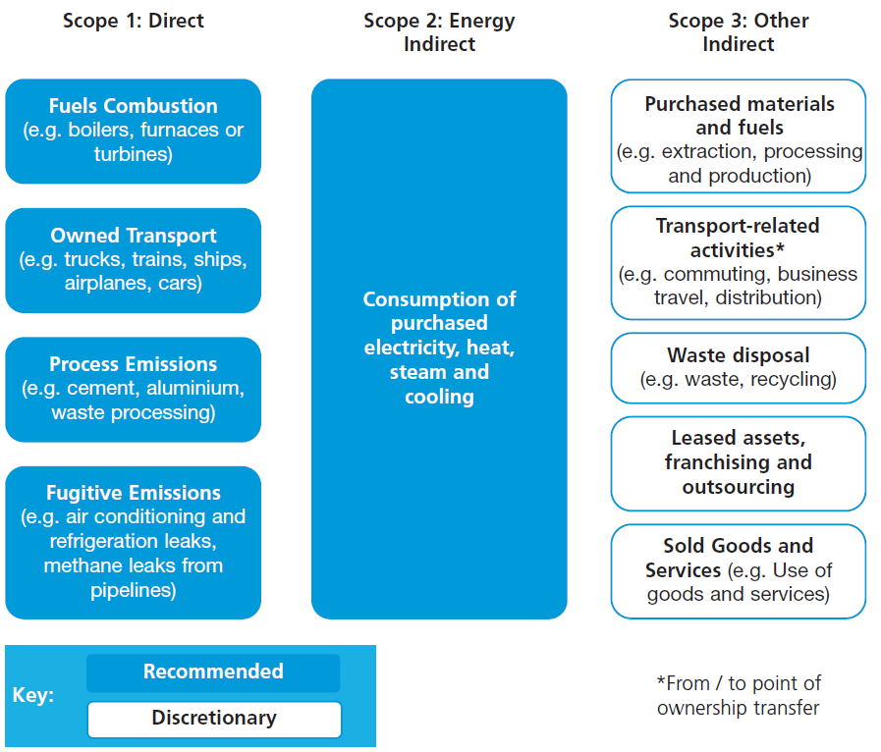
Source: adopted from DEFRA 2009

Inventory of emissions
For scope 1 and scope 2 emissions, the following tables illustrate the type of data that constitutes a typical emissions inventory.

Emissions disaggregated by source types
Scope 1: Direct Emissions from Owned/Controlled Operations
- Direct Emissions from Stationary Combustion
- Direct Emissions from Mobile Combustion
- Direct Emissions from Process Sources
- Direct Emissions from Fugitive Sources
- Direct Emissions from Agricultural Sources
Scope 2: Indirect Emissions from the Use of Purchased Electricity, Steam, Heating and Cooling
- Indirect Emissions from Purchased/Acquired Electricity
- Indirect Emissions from Purchased/Acquired Steam
- Indirect Emissions from Purchased/Acquired Heating
- Indirect Emissions from Purchased/Acquired Cooling

Emissions disaggregated by facility (recommended for individual facilities with stationary combustion emissions over 10,000 mtCO2e)
Facility | Scope 1 emissions

Emissions disaggregated by country
Country | Emissions (specify Scopes included)

Information about emissions-reduction targets
Companies may want to set an emissions-reduction target, to help contextualize their emissions-reduction efforts. Typically, targets are established in absolute or relative (so-called intensity-based) terms.
Definitions:
Absolute targets: they compare greenhouse-gas emission levels in the target year to the levels in the base year.
Intensity targets: they measure decreases in greenhouse-gas emissions relative to a certain parameter, such as the tonne of product produced, or the floor space.

Type of target
What type of target your company is pursuing?
Absolut target
Intensity target

Link of the target to base year:
What type of target base year your company is pursuing?
Fixed target base year
Rolling target base year (the emissions are always compared to the previous year).

Decide on the target boundary
Definition:
The target boundary explains what has been included or covered by the target – for example, the emissions sources and activities concerned, or the geographic operations concerned. Stated differently, a target may coincide with the corporate carbon footprint, or may be a sub-set of it. The latter makes sense, for example, in the context of an emissions trading scheme that regulates only of sub-set of the company’s greenhouse-gas emissions.

What target boundary your company has defined?
Define the target completion date
Third party verification
Has the inventory been verified by an accredited third party?
No
Yes (if yes, fill in verifier contact information below and attach verification statement)
Date of verification: MM/DD/YYYY
Verifier Name:
Contact information:

Offsets
Report on offsets that have been bought or developed outside the inventory boundary
Greenhouse-gas emission levels (mtCO₂e) | Type of offset project | State whether the offsets were verified/certified and/or approved by an external greenhouse-gas emissions-reduction programme

Report on cutbacks inside the inventory boundary that have been traded/transferred as offsets to a third party
Greenhouse-gas emission levels (mtCO₂e) | Type of offset project | State whether the offsets were verified/certified and/or approved by an external greenhouse-gas emissions-reduction programme

Additional information companies may want to provide

Emissions from greenhouse-gases not covered by the Kyoto Protocol

Data and information on the reasons of emissions changes (such as process changes, efficiency improvements, or plant closures) that did not trigger a recalculation of the base year

Greenhouse-gas emissions data for all years between the base year and the reporting year (including details of and reasons for recalculations, if appropriate)

Relevant performance indicators, such as emissions per kilowatt-hour generated, or per unit of turnover

An outline of any greenhouse-gas management or reduction programmes or strategies

Information on any predetermined provisions addressing greenhouse gas-related risks and obligations

An outline of any external assurance provided and a copy of any verification statement, if applicable, of the reported emissions data

Information on the quality of the inventory (notably, regarding the uncertainty of the emission estimates) as well as an outline of policies in place to improve inventory quality

Information on any greenhouse-gas emissions sequestration

Annex: recommended check list of information to report

Relevant information | Category
General company information | company information
State the reporting period covered | reporting period
State the reason for any significant changes in emissions since previous year | changes in emissions and the relevant reasons
State the measuring and reporting approach followed | Organisational boundary
State the scopes included.  Companies should provide a list specifying the activity types included in each scope | Operational scops
Provide detail of any specific exclusions of emissions from scopes 1 and 2 | Operational scops
State the conversion tools / emission factors you used | Operational scops
Provide a breakdown by country of total GHG emissions | Operational scops
Provide detail of any exclusions of countries if a global total is reported | Operational scops
Provide detail of any exclusions of countries if a global total is reported | Operational scops
State the base year chosen and approach used to set the base year | base year
State base year recalculation policy | base year
State appropriate context for any significant emissions changes that trigger base  year emissions recalculation (acquisitions/divestitures, outsourcing/insourcing,  changes in reporting boundaries or calculation methodologies, etc.). | base year
State your target, including scopes covered and target completion date. Provide  a brief overview of progress towards target. | Target
State the name of the person(s) responsible for achievement of this target and their position in your organisation | Target

Relevant information | Category
State the reason for your intensity measurement choice | intensity measurement
State the reason for any significant changes in your intensity measurement from  the previous year | intensity measurement
Provide an outline of any external assurance received and a copy of any  assurance statement, if applicable | External Assurance  Statement
For purchased carbon credits state the reduction in tonnes of CO2e per year | Carbon Offsetting
State the type of carbon credit (Kyoto compliant or non-Kyoto compliant credit)  • If carbon credits are Kyoto-compliant, organisations should specify which  external GHG programme has approved them, provide the name of the  supplier and a hyperlink to the project documentation where possible  • If carbon credits are non-Kyoto compliant, organisations should provide the  name of the supplier, a hyperlink to the project documentation where possible,  details of who developed the quantification methodology, how the project was  validated and verified and how other ‘good quality criteria’ were met. | Carbon Offsetting
For purchased green tariffs state the reduction in tonnes of CO2e per year | green tariffs
State the supplier and the name of the tariff | green tariffs
State the additional carbon saving associated with the tariff as a percentage (%) | green tariffs
State in MWh the amount of electricity generated from owned or controlled sources. State if the owned or controlled source is onsite or offsite. | electricity generation
Source:
DEFRA, 2009: Guidance on how to measure and report your greenhouse gas emissions. Department for Environment, Food, and Rural Affairs. United Kingdom.

ERM, “Company greenhouse-gas emissions reporting – a study on methods and initiatives”. Report Commissioned by the European Commission’s Directorate-General Environment (ENV.G.2/ETU/2009/0073). Manchester: Environmental Resources Management (2010)
With regard the issues of robustness, the ISO protocol finds itself in a rather unique position: it has both advocates, who praise its consistency with other quality standards, and detractors, who claim that it needs to be used in conjunction with other protocols that provide more detailed guidance on emissions accounting.
The GHG Protocol Corporate Standard makes no specific recommendations as to what constitutes “significant”. However, some greenhouse-gas emission-reduction programmes do specify numerical significance thresholds. For example, in the California Climate Action Registry, the change threshold is 10 percent of the base year emissions, “determined on a cumulative basis from the time the base year is established”.
DEFRA, 2009: Guidance on how to measure and report your greenhouse gas emissions. Department for Environment, Food, and Rural Affairs. United Kingdom.

